SOFT COMPUTING
ASSIGNMENT -5
Perumalla Dharan
AP21110010201

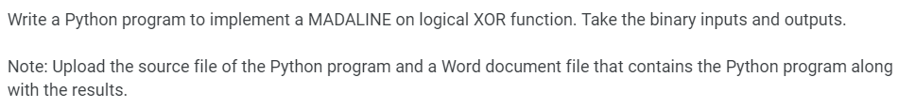

import numpy as np

class MADALINE:
def __init__(self, learning_rate=0.1, iterations=10000):
self.learning_rate = learning_rate
self.iterations = iterations

self.w = np.random.uniform(-0.5, 1, (2, 2))
self.b1 = np.random.uniform(-0.5, 1, 2)

self.v = np.random.uniform(-0.5, 1, (2, 1))
self.b2 = np.random.uniform(-0.5, 1, 1)

def fx(self, x):
return np.where(x >= 0, 1, 0)

def predict(self, X):

z_in = np.dot(X, self.w) + self.b1
z_out = self.fx(z_in)

y_in = np.dot(z_out, self.v) + self.b2
y_out = self.fx(y_in)

return y_out

def train(self, X, y):
for epoch in range(self.iterations):
for i in range(len(X)):

z_in = np.dot(X[i], self.w) + self.b1
z_out = self.fx(z_in)

y_in = np.dot(z_out, self.v) + self.b2
y_out = self.fx(y_in)

if y_out != y[i]:
if y[i] == -1:
for j in range(len(z_in)):
if z_in[j] > 0:

self.w[:, j] += (self.learning_rate * (X[i]) *(y[i]-z_in[j].item()))
self.b1[j] += (self.learning_rate * (y[i]-z_in[j].item()))

elif y[i] == 1:

closest_to_zero_index = np.argmin(np.abs(z_in))

self.w[:, closest_to_zero_index] += (self.learning_rate * X[i] *(y[i]-z_in[j].item()))
self.b1[closest_to_zero_index] += (self.learning_rate *(y[i]-z_in[closest_to_zero_index].item()))

# Input Data for training (XOR logic)
X = np.array([[0,0],
[0, 1],
[1, 0],
[1, 1]])

# Input Data for testing (same as XOR)
Z =np.array([[0,0],
[0, 1],
[1, 0],
[1, 1]])

y = np.array([[0], [1], [1], [0]])

madaline = MADALINE(learning_rate=0.1, iterations=10000)

madaline.train(X, y)

predictions = madaline.predict(Z)

# Display results
print("Testing Data:")
print(Z)
print("Predictions after training:")
print(predictions)

